1. Which are the top three variables in your model which contribute most towards the probability of a lead getting converted?

Answer:

To answer this question, we can look at the coefficients of the final model used for prediction :

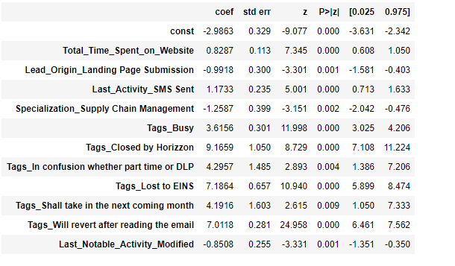

Going by the coefficients of this model we can conclude that below variables contribute the most towards lead conversion:

Tags_Closed by Horizzon, Tags_Lost to EINS, Tags_Will revert after reading the email.

Going by the Exploratory data analysis plots below variables were found useful:

Total Time spent On Website – The more time spend on website the higher likelihood of the lead getting converted.

Do Not Email – Leads who have answered No for Do Not Email, ie the people who are fine with getting an email are more likely to get converted.

Last Activity – Leads for whom Last Activity is SMS Sent and Email Opened are more likely to get converted than other activities.

Tags – Leads for whom Tag is "Will revert after reading the email" are more likely to get converted.

1. What are the top 3 categorical/dummy variables in the model which should be focused the most on in order to increase the probability of lead conversion?

Answer:

Again going by the model coefficients the variables found to contribute the most towards lead conversion, also happen to be dummy variables:

Tags_Closed by Horizzon, Tags_Lost to EINS, Tags_Will revert after reading the email.

Looking at the plots, below were found to be important

Last Notable Activity/Last Activity = SMS Sent

Tags = Will Revert After Reading the Email

Last Activity = Email Opened.

1. X Education has a period of 2 months every year during which they hire some interns. The sales team, in particular, has around 10 interns allotted to them. So during this phase, they wish to make the lead conversion more aggressive. So they want almost all of the potential leads (i.e. the customers who have been predicted as 1 by the model) to be converted and hence, want to make phone calls to as much of such people as possible. Suggest a good strategy they should employ at this stage.

Answer: Currently the cutoff percentage has been kept at 0.57 in the model by looking at Sensitivity-Specificity-Accuracy tradeoff a well as Precision-Recall tradeoff.

During these 2 months the cutoff could be reduced to as low as 0.20 to 0.25 so as to predict maximum leads as possible converts and call them with Selling offers,

1. Similarly, at times, the company reaches its target for a quarter before the deadline. During this time, the company wants the sales team to focus on some new work as well. So during this time, the company’s aim is to not make phone calls unless it’s extremely necessary, i.e. they want to minimize the rate of useless phone calls. Suggest a strategy they should employ at this stage.

Answer: Currently the cutoff percentage has been kept at 0.57 in the model by looking at Sensitivity-Specificity-Accuracy tradeoff a well as Precision-Recall tradeoff.

During this time the cutoff can be kept very high around 0.80 to 0.85 to only call the most likely converts.